**Assignment No. 05**

**Q.1. For your project draw DFD diagram.**

**1) Level 0 DFD**

**2)Level 1 DFD**

**3) Level 2 DFD (if required)**

**Ans.**

1. **Context Level DFD (Level 0 DFD):**

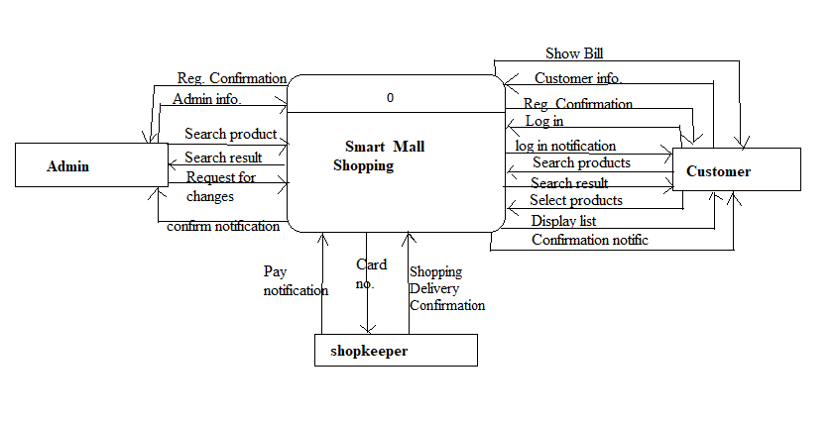

1. **Level 1 DFD:**

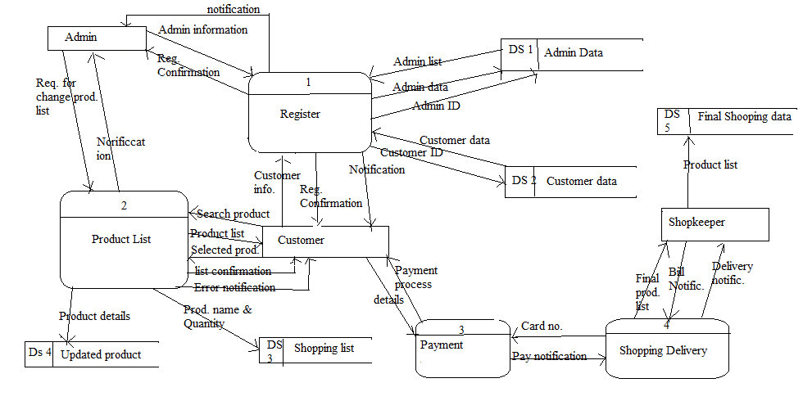

**Q.2. Transform the above DFD into structural chart.**

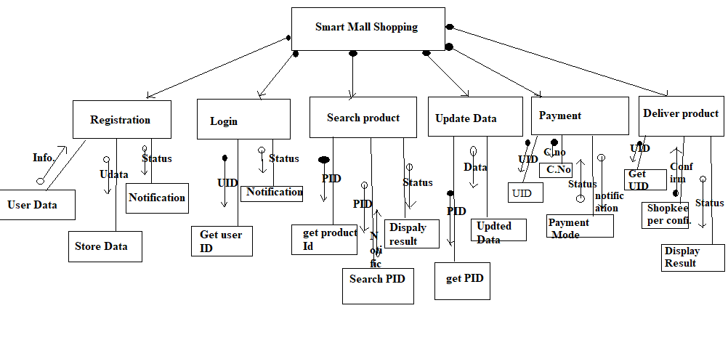

**Q.3.Identify all data stores from DFD**

**1) write data dictionary:**

**1.**

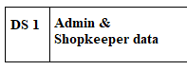

**Attribute and datatypes:**

1. AID- char (20)
2. SID- char (20)
3. Same- char (20)
4. S_Conatct- char (100)
5. AName- char (100)
6. ADOB- date
7. Jdate- date
8. AAddress- Char (150)
9. AContact No. – int

**2.**



Attributes and datatype:

1. CID- char (20)
2. CName- Char (100)
3. CAddress- Char (150)
4. CcontantNo. – int

**3.**



Attributes and datatypes:

1. PID- Char (20)
2. Pname- Char (100)
3. Quantity- int

**4.**



Attributes and datatypes:

1. PID- char (20)
2. Pname – Char (100)

**5.**

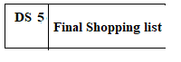

Attributes and datatypes:

1. PID- Char (20)
2. Pname- (100)
3. Total_amount- int
4. Payment_mode- char (20)
5. Payment_notification- char (1)
6. **Draw ER diagram:**

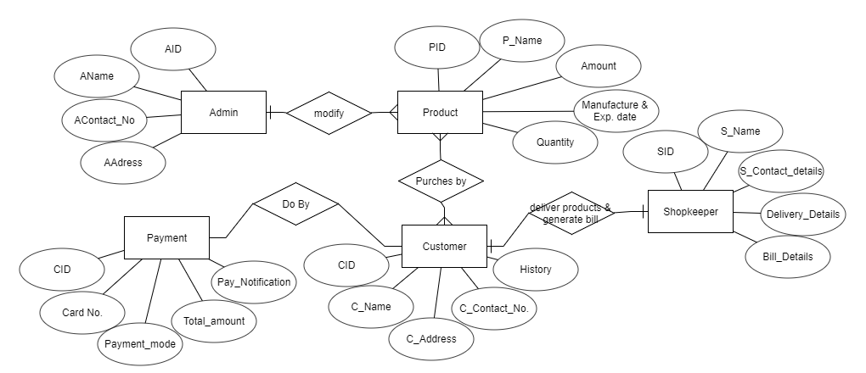

1. **Translate Model to physical Schema.**
2. **Create table query:**

**Admin:**

Create table Admin

(

AID int Not Null,

Aname char (20),

A_Conatct_no. int,

A_Address char (100)

)

**Shoppkeeper:**

Create table shopkeeper

(

SID int Not Null,

S_Name char (20),

S_Conatct_no int,

S_Address char (100)

)

**Customer:**

Create table customer

(

CID int Not Null,

C_Name char (20),

C_Conatct_no int,

C_Address char (100)

)

**Products:**

Create table products

(

PID int Not null,

Pname char (50),

P_Amount int,

P_Manf_date date,

P_Exp_date date,

P_Qunatity int

)

1. **Select query:**

**Admin:**

Select * from admin where (AID=1)

**Customer:**

Select * from customer where (CID=1)

**Product:**

Select * from product where (PID=1)

1. **Delete query:**

**Admin:**

Delete * from admin where(Aname=’ABC’)

**Customer:**

Delete * from product where(Pname=’XYZ’)

1. **Update query:**

**Customer:**

UPDATE Customer

SET C_Conantact=5323268315

Where CID=90;

**Product:**

UPDATE product  
SET P_Quantity = 20  
WHERE PID=5;